Overdraft Tolerance Opt-in/out

[BANNO.ODTOPTIN.V1.POW]

Program Overview

Table of Contents

Overview 1

UX Run-Time Detail 1

PowerOn Run-Time Detail 3

Program setup & Installation 3

Required Files 3

Installation steps 3

Configuration Letter file 4

Database Interaction 4

Data Sources 4

Transactions / File Maintenance Performed 4

Additional Information 4

Share Tracking Records 4

Program Change History 5

BANNO.ODTOPTIN.V1.POW

# Overview

## The Overdraft Tolerance Opt-in/out PowerOn allows the end-user to acknowledge the credit union’s terms and fees and opt-in or out of overdraft services on their account. The member may opt-in or opt-out on a share-by-share basis. The status of any given share and the date last set will be recorded by the program in a share tracking record.

# UX Run-Time Detail

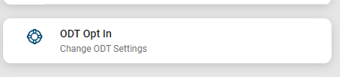

Upon running the program, the Banno UX displays a list of the eligible shares for which the user can change the Overdraft Tolerance (ODT) settings.

The shares which the user has already opted in for will be preselected. The user can opt out of those shares by deselecting them. The user can also select additional shares to opt in.

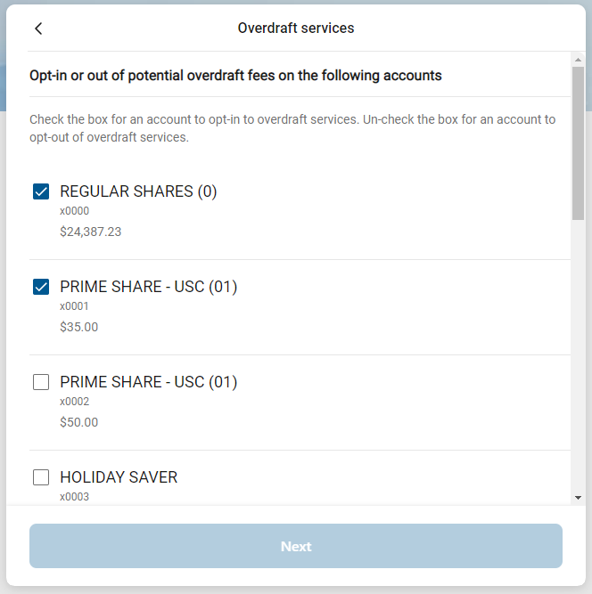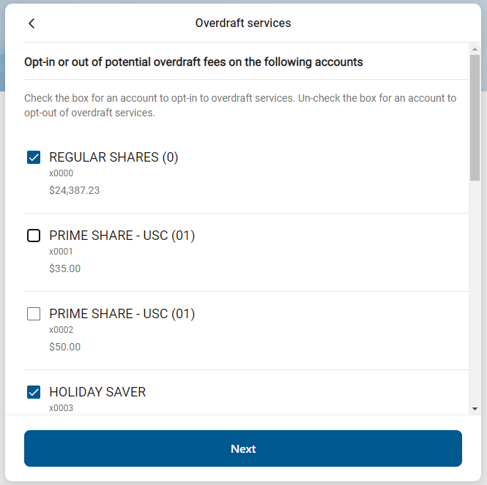

Upon submitting the form, the Terms and Conditions will be displayed for the member to accept.

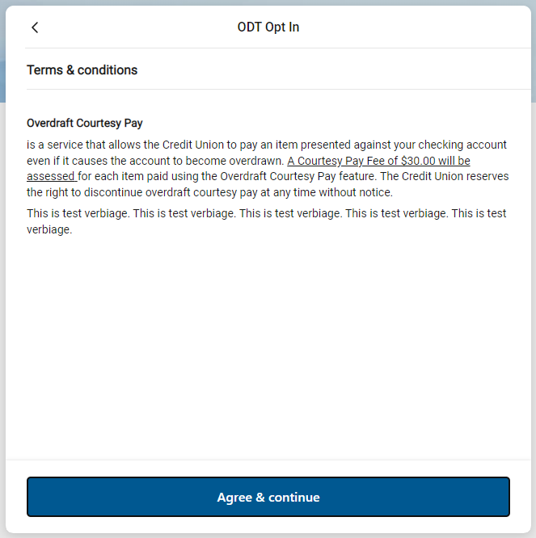

A summary screen is then displayed for the member to view and confirm. Upon confirming the ODT settings are immediately updated.

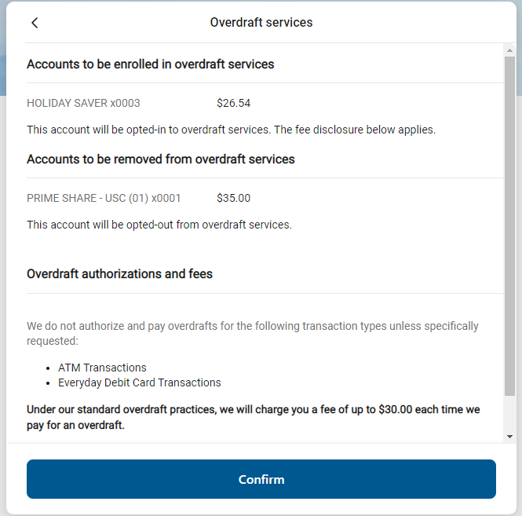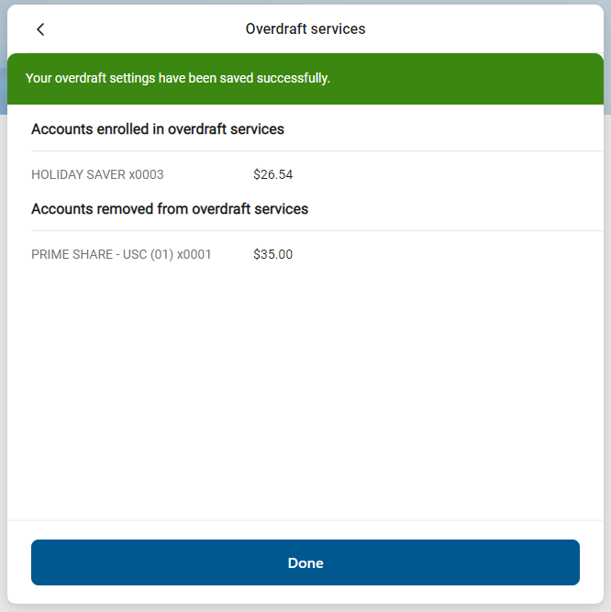

# PowerOn Run-Time Detail

When first run by the member, the program reads the various parameter settings from the Letter file, and based upon these settings and values, determines whether the account is eligible to update the share ODT settings. If the account is eligible, the program looks for the share tracking record pertaining to ODT settings and then generates a list of eligible shares identifying the opt-in or opt-out status for each share. This data is then passed to the Banno UX for display to the member.

Once the member has made their selections and those selections are passed back to the PowerOn by the Banno UX, the program reads the Letter file to obtain the Terms and Conditions. This data is then passed to the Banno UX for display for the member to view and approve.

Upon approval, the PowerOn will update the member’s share and create/ update the related share tracking record as needed.

# Program setup & Installation

Upload the necessary files to their respective folders. The easiest way to upload them is to use the Episys PC Transfer function.

## Required Files

* + REPWRITERSPECS folder
* BANNO.ODTOPTIN.V1.POW (Main PowerOn Program)
  + Standard PowerOn library include files which should already be in your system:
  + RD.GETDATA.DEF
  + RB.LISTEXPAND.DEF
  + RB.LISTEXPAND
  + LETTERSPECS folder
* BANNO.ODTOPTIN.V1.CFG (Main program configuration Letter file)

## Installation steps

* Upload files to their respective directories
* Install the PowerOn program for demand use
* Add the PowerOn program name to SymXchange Common Parameters
* In Device Control take SymXchange – Banno Off Host
* Put SymXchange- Banno back On Host and verify Status = On Host
* Update the settings in the configuration Letter file. The configuration Letter file contains details for the various settings.
* Add the program to Banno People

## Configuration Letter file

The configuration Letter file allows certain aspects of the program to be customized to better meet your specific needs. Among the options which can be set are:

* Identify the share tracking type used to store the current ODT status for each share.
* Determine which account and share types are ineligible.
* Determine which account and share level warning codes to exclude.
* Determine if the program should update the share’s ODT Auth/ Fee Option 1 and ODT Source Code List 1 fields at the same time the share is updated and if so, identify the value each should be set to if the member opts in or opts out.
* Determine if the program will set the share’s Overdraw Tolerance amount by share type.
* Set the Terms & Conditions, fee disclosure, revocation instructions, service instructions, Opt-in information, and Opt-Out information verbiage.

The configuration Letter file contains full instructions on setting these run-time parameters. Do pay close attention when selecting your options making sure to set each option within the required parameters.

# Database Interaction

## Data Sources

Data utilized by the program is pulled from the following sources:

* Member’s open share records
* ODT share tracking records

## Transactions / File Maintenance Performed

* The program updates the following fields in the share record.
  + AUTHFEEOPTION:1 ODT Auth/ Fee Option
  + ODTAUTHFEESRCCODELIST:1 ODT Source Code List
  + OVERDRAFTTOLERANCE Overdraw Tolerance Amount
* The program creates and/ or updates the ODT share tracking record. The share tracking record contains the following information:
  + USERCODE1 ODT status
  + USERDATE1 Date of ODT status update

# Additional Information

### Share Tracking Records

The program uses the existence of these tracking records along with the AUTHFEEOPTION:1 and ODTAUTHFEESRCCODELIST:1 fields on the share record to identify/ update the ODT settings for the share. There will be a share tracking record created under each share once the share is set as opted in or out.

# Program Change History

Ver. 1.0.0 07/14/20: T. Kainz- Banno

* + Original Programming

Ver. 1.0.1 09/18/2020: T. Kainz- Banno

* + Corrected end of the line spacing for disclosures.

Ver. 1.0.2 02/11/21: T. Kainz- Banno

* + Modification to terms, disclosures, and revoke instructions to allow for a blank line.
  + Added program info to JSON output.

Ver. 1.0.3 09/03/21: T. Kainz- Banno

* Increased the Table of Contents and Disclosure lines max to 999 and the revoke instructions to 99.

Ver. 1.0.4 07/29/22: R. Robison- Banno

* Added Service Instructions, Opt-in information, and Opt-out information soft text.
* Added feature for setting the Overdraw Tolerance field on the share record.